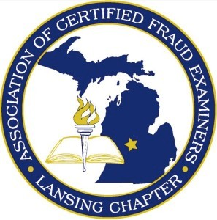LANSING CHAPTER OF THE ASSOCIATION OF CERTIFIED FRAUD EXAMINERS

# INHERITANCE SCAMS

Leo received a letter from a lawyer in Portugal on beautiful fancy letterhead announcing a very interesting proposal. The letter used legal jargon to explain that Leo was being offered a share in an extremely large inheritance which was left behind by the lawyer’s late client.

The client had no immediate family in Portugal and a search in Europe found no legitimate relatives of the deceased. The lawyer devised a scheme in which he would claim that Leo was a distant relative and entitled to the entire fortune since Leo shared the same surname as the late client. Leo and the lawyer would then split the inheritance.

Leo was convinced the letter was authentic since it appeared to have a Portuguese stamp on it. Leo had come across the once-in-a-lifetime opportunity everyone waits for all their lives.

Leo contacted the lawyer and was positive this scheme would work. Leo’s share of this fake inheritance would be $550,000. The lawyer insisted the money would be paid out in American dollars as well. The lawyer only needed Leo to pay a few fees and taxes that the Portuguese authorities required for out-of-country payouts of personal inheritances.

Leo was more than happy to send out a check for $10,000 to get the paperwork started. After spending over $30,000, it became quite clear to Leo that he had lost all his savings trying to gain an inheritance that never actually existed.

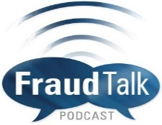**IN THIS ISSUE**

**Fraud Talk Podcast**

**The Dark Web: A Means to Commit Fraud on a Grander Scale**

In this episode of Fraud Talk, Emily Wilson, CFE, Vice President of Research at Terblum Labs and upcoming speaker at the 30th Annual ACFE Global Fraud Conference, discusses the dark web and what fraud examiners should know about this mysterious, misunderstood part of the Internet. This podcast is a product of the ACFE and may be downloaded at <https://s138.podbean.com/pb/d2971162928c311f7e0b8ce2e4ddd786/5c9e77ea/data1/fs103/2004630/uploads/The_Dark_Web-_A_Means_to_Commit_Fraud_on_a_Grander_Scale_Fraud_Talk-_Courtney_Howell_Emily_Wilson-_Episode_78.mp3?pbss=b4df0bad-ea5d-5b8a-8efc-7f4102d35f08>

### Classic Scams

**Fraud Talk Podcast – The Dark Web: A Means to Commit Fraud on a Grander Scale**

**Upcoming Events**

**In The News**

**Extreme Couponing or Coupon Fraud?**

# UPCOMING EVENTS



**LOCAL:**

**Employment Law for Managers**

April 16, 2019

Seminar – 9:00 a.m. to 3:00 p.m. – Walsh College, Novi

Learn More at <https://www.michamber.com/seminars/employment-law-managers>

**Ethics – Lessons From an $8.5 Million Fraud**

April 10, 2019

Seminar – 2:00 p.m. to 3:50 p.m. Okemos Conference Center, Okemos

Learn More at <https://www.agacgfm.org/Webinars/2018-2019-Webinars/Ethics-(1).aspx>

**Advanced Risk Based Auditing**

2 sessions: April 16 & 18, 2019 or April 23 & 25, 2019

Webinar – 12:00 p.m. to 3:20 p.m.

Learn More at <https://na.theiia.org/training/Pages/Event-Search.aspx>

***SAVE THE DATES!  
Lansing Chapter of the ACFE – Spring Fraud Conference***

*Conducting Internal Investigations*

*May 16 & 17, 2019 – Lansing*

**NATIONAL:**

**Government Fraud**

April 08-09, 2019

Denver, CO

Learn More at <https://www.acfe.com/events.aspx?id=4295003272>

**7th Annual Fraud & Corruption Awareness Seminar (for IIA, ACFE, and ISACA members)**

May 13, 2019

Pittsburgh, PA

Learn More at <https://www.eiseverywhere.com/ehome/index.php?eventid=395981&>

**ACFE GLOBAL FRAUD CONFERENCE**

June 23-28, 2019

Austin, TX

Learn More at https://www.fraudconference.com/30annual/sessions.aspx?utm_source=acfedotcom&utm_medium=hero&utm_campaign=30FCutm_source=acfedotcom&utm_medium=hero&utm_campaign=30th-Annual-Sessions-Announced

*If you have an event that you would like posted in our newsletter or if you wish to share an article, please contact Melanie Marks at* [*lacfemrmarks@gmail.com*](mailto:lacfemrmarks@gmail.com)



**Den of Thieves** James B. Stewart

Den of Thieves tells for the first time how four of the biggest names on Wall Street – Michael Milken, Ivan Boesky, Martin Siegel, and Dennis Levine – created the greatest insider-trading ring in financial history and almost walked away with billions, until a team of downtrodden detectives triumphed over some of America’s most expensive lawyers to bring this powerful quartet to justice.

**Fraud Analytics Using Descriptive, Predictive, and Social Network Techniques**

Bart Baesens, Veronique Van Vlasselaer, and Wouter Verbeke

An authoritative guidebook for setting up a comprehensive fraud detection analytics solution. Early detection is a key factor in mitigating fraud damage, but it involves more specialized techniques than detecting fraud at the more advanced stages. This invaluable guide details both the theory and technical aspects of these techniques, and provides expert insight into streamlining implementation. Coverage includes data gathering, preprocessing, model building, and post-implementation, with comprehensive guidance on various learning techniques and the data types utilized be each.

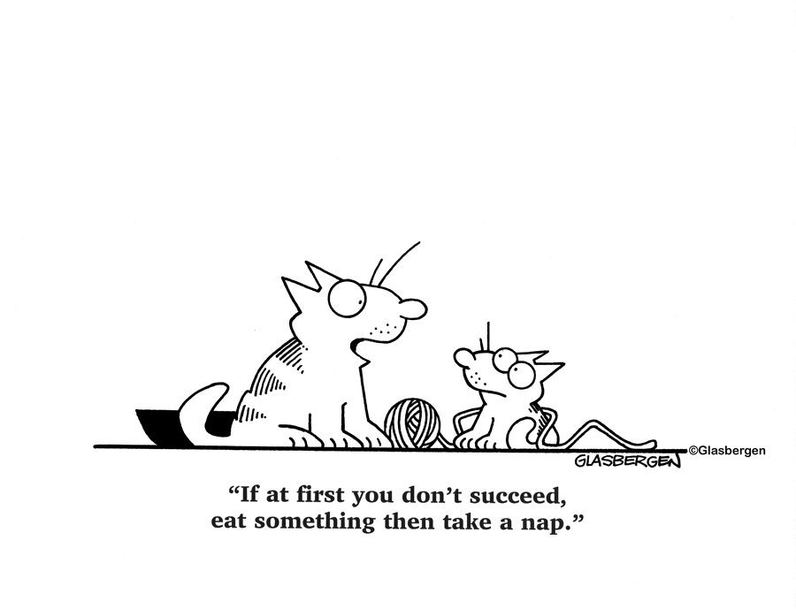

IN THE NEWS

*Avenatti confident “justice will be done” in his fraud case*

<https://www.cnbc.com/2019/04/01/michael-avenatti-confident-justice-will-be-done-in-his-fraud-case.html>

*Ethics complaints against Paul Manafort’s judge T.S. Ellis reportedly dismissed*

<https://www.cnbc.com/2019/04/01/ethics-complaints-against-paul-manaforts-judge-ts-ellis-reportedly-dismissed.html?forYou=true>

*UK fraud office failed to get key Qatar documents for Barclays trial*<https://www.cnbc.com/search/?query=Fraud%20and%20false%20statements?&qsearchterm=fraud>

*Two Corporate Executives Indicted in First-Ever Criminal Prosecution for Failure to Report Under Consumer Product Safety Act*

<https://www.justice.gov/opa/pr/two-corporate-executives-indicted-first-ever-criminal-prosecution-failure-report-under>

*Defendant Who Exploited Opioid Addictions of Young Women Convicted of Crimes Related to Drug Trafficking and Prostitution*<https://www.justice.gov/opa/pr/defendant-who-exploited-opioid-addictions-young-women-convicted-crimes-related-drug>

*Law Enforcement Officers Charged in Federal Court With Taking Bribes to Falsify Immigration Documents and Protect Drug Trafficking Proceeds*

<https://www.justice.gov/usao-sc/pr/law-enforcement-officers-charged-federal-court-taking-bribes-falsify-immigration>

*More Charges Announced in Ongoing Investigation into Bid Rigging and Fraud Targeting Defense Department Fuel Supply Contracts for U.S. Military Bases in South Korea*

<https://www.justice.gov/opa/pr/more-charges-announced-ongoing-investigation-bid-rigging-and-fraud-targeting-defense>

*Manhattan Jeweler Pleads Guilty to Insider Trading eaHH*

<https://www.fbi.gov/investigate/white-collar-crime/news>

*Man Sentenced to Prison for $1.8 Million in Real Estate Fraud Scheme*

<https://www.fbi.gov/investigate/white-collar-crime/news>

*Massachusetts Insurance Agency CEO Charged in $270K Insurance Fraud Scheme*

<https://www.insurancejournal.com/topics/insurance-fraud/>

Extreme Couponing or Coupon Fraud?

By Stephanie Wood, CPA, CFE, CIA  
Stephanie is part of the Leadership Team at Stonebridge Business Partners.  
stonebridgebp.com

Whether you regularly cut coupons from the Sunday paper or search for promotional codes while doing online shopping, coupons can be a great way to provide consumers with a discount on various grocery, clothing, and personal care items. With several websites out there such as RetailMeNot, Coupons.com, and The Krazy Coupon Lady, consumers don’t have to look very hard to find deals. While coupons can offer great discounts, it is also important to remember that there are rules and regulations that need to be followed when using coupons. If not used properly, innocent couponing can become coupon fraud.

The Coupon Information Corporation (“CIC”), a not-for-profit association of consumer product manufacturers dedicated to fighting coupon mis-redemption and fraud, defines coupon fraud as someone intentionally using a coupon for a product that he/she has not purchased or otherwise fails to satisfy the terms and conditions for redemption, when a retailer submits coupons for products they have not sold or that were not properly redeemed by a consumer in connection with a retail purchase; or when coupons are altered/counterfeited. Since its inception in 1985, the CIC has exposed fraud schemes involving more than $750 million.

While it might initially seem insignificant compared to all of the other transactions being processed by retailers on a daily basis, the cost of coupon “mis-redemption” to manufacturers is estimated to be between $300 and $600 million per year. One of the unfortunate consequences is that retailers have to raise prices to mitigate their losses, ultimately costing consumers more money in the end.

Additionally, coupon fraud can actually lead to some pretty significant fines and even jail time, depending on how extreme it is. A man in Michigan was sentenced to 10 years in federal prison for running a scheme at a coupon redemption center. He collected coupons from stores and sorted them to get paid by the coupon issuer. According to the CIC’s website, the longest prison sentence ever imposed for coupon fraud was 17 years and the highest financial penalty imposed was $5 million.

What does coupon fraud look like?

So what does coupon fraud look like? The following are examples of the most common forms of coupon fraud:

* Decoding: Intentionally applying coupons to the wrong products and pressuring cashiers to accept them. An example would be purchasing a different product/size than what is offered on the coupon.
* Mass printing/gang cut coupons: Printing coupons to use multiple times to redeem at different stores.
* Coupon modification: Adjusting coupon terms of expiration, value, and even the barcode.
* Buying and selling coupons: Non-transferability is part of the usage agreement on all U.S. coupons. While sharing with friends and family is not prohibited, the act of collecting coupons for profit increases the risk of ending up with counterfeit coupons.
* Using expired coupons: Most stores do not allow expired coupons. This should only be acceptable if you have an attached rain check that you obtained before the sale was over.
* Shoplifting newspapers to get the coupons: Consumers stealing newspapers to get the weekly coupons for free.
* Reselling products purchased with coupons: Coupons typically state that it cannot be used on items for resale.

How to avoid coupon fraud

Consumers should be mindful of where they are getting coupons from, and know the basics when it comes to coupon standards. This can help to be able to identify a fake. Below are the most common red flags to look for:

* Coupons that are valued at more than the actual price of an item
* Coupons without barcodes
* Coupons that do not require a purchase to be made to redeem
* Coupons that do not have conditions of usage in small print
* Paying for a coupon

The CIC is a good resource to use as they regularly update their website with the most recent counterfeit coupon notifications and have good tips on how coupons should be used and what activities are prohibited. So far in the month of January 2019, the CIC has already posted 218 notifications of counterfeit coupons that should not be accepted by retailers.

What can you do?

If you observe something that appears to be coupon fraud, it is important to report it right away. You can file a complaint with the U.S. Postal Inspection Service, Federal Bureau of Investigation, Federal Trade Commission, or the Internal Revenue Service. In the end, if we all use coupons appropriately, it can be a great way to get discounts on a variety of items. However, if consumers continue to misuse them at the current rate, retailers will be forced to restrict their use or raise prices in response. 

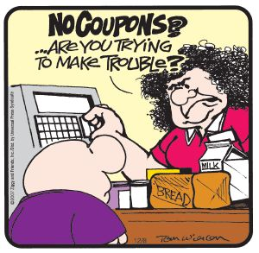

# QUOTE OF THE MONTH

**"Any informed borrower is simply less vulnerable to fraud and abuse.”  
 Alan Greenspan**